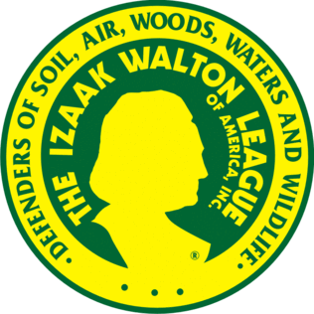

HELP US SAVE THE IKES!!
COME JOIN US AT OUR MONTHLY MEETINGS
THE FIRST SUNDAY OF EVERY MONTH AT NOON.
AT THE ARGOS IZAAK WALTONS.

